Practical 8:
Web Trigger – Control GPIO from Web Server
- Host a simple Flask web app (Raspberry Pi) or ESP Web Page (Arduino)
- Control a set of LEDs via buttons on a webpage
- Ensure real-time response and feedback

LED Connections
LED | Arduino Pin | Series Resistor | GND
RED LED | Pin 8 | 220Ω | GND
YELLOW LED | Pin 9 | 220Ω | GND
GREEN LED | Pin 10 | 220Ω | GND

Wiring instructions
- Place three LEDs on the breadboard
- Connect each LED’s cathode (-) to GND (use the blue rail)
- Connect each anode (+) to:
  - Resistor → Arduino pin
- Pins to use:
  - Pin 8 → RED
  - Pin 9 → YELLOW
  - Pin 10 → GREEN

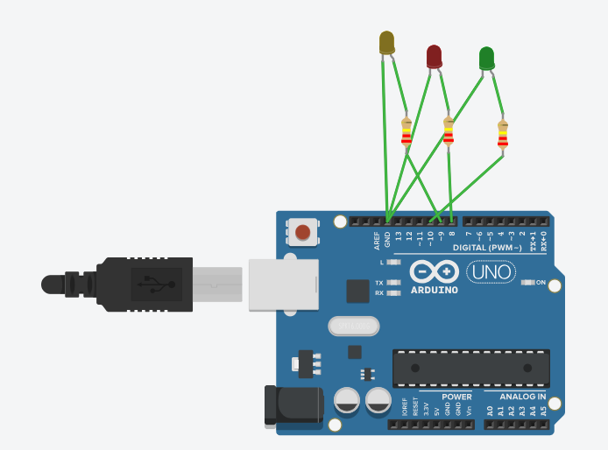

Write following code:
int redLED = 8;
int yellowLED = 9;
int greenLED = 10;

void setup() {
pinMode(redLED, OUTPUT);
pinMode(yellowLED, OUTPUT);
pinMode(greenLED, OUTPUT);

Serial.begin(9600);
Serial.println("Send r/y/g to toggle LEDs");
}

void loop() {
if (Serial.available()) {
char c = Serial.read();

if (c == 'r') digitalWrite(redLED, !digitalRead(redLED));
if (c == 'y') digitalWrite(yellowLED, !digitalRead(yellowLED));
if (c == 'g') digitalWrite(greenLED, !digitalRead(greenLED));
}
}

Output:
• When you run the simulation, all LEDs start OFF.
• You type a letter in the Serial Monitor:
- r → Red LED turns ON (or OFF if it was already ON)
- y → Yellow LED turns ON/OFF
- g → Green LED turns ON/OFF
• Each LED toggles every time you type its letter.
• So it simulates controlling LEDs from a web page, but using the Serial Monitor.

